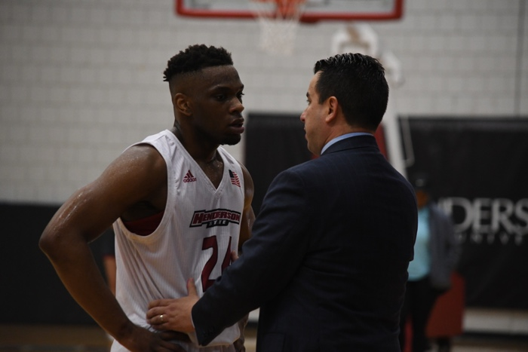

PLACE STAMP HERE

“The facilitation of our summer basketball camps is one of our favorite components of our program. Our camps have grown exponentially and we are excited to return to the offering of basketball camps over the summer. Our staff and players pride themselves on teaching the fundamentals to youth around the state of Arkansas. ”

- *Coach Jimmy Elgas*

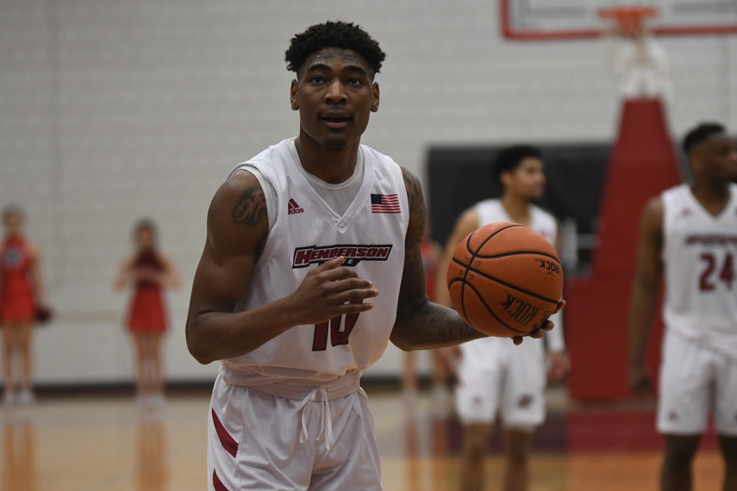

**Reddie Basketball Camps**

1100 Henderson St. Box 7630

Arkadelphia, AR 71999

**REDDIE**

**BASKETBALL CAMPS**



**\*OPEN TO ALL BOYS AND GIRLS\***

***Day Camp June 9-12***

***Shooting Camps***

***June 23-24 &July 21-22***

***Elite Fundamental Camps***

***June 23-24 &July 21-22***

**Day Camp** **$125**

**2025 Reddie Basketball Camp Application**

Name

PLEASE CHECK THE CAMP(S) ATTENDING

Grades K-12 | 9am – Noon Monday - Thurs

All day camps are open for boys and girls,

all campers receive a Henderson State t- shirt.

Day camp format includes an emphasis on most basketball fundamentals including ball handling, passing, shooting, individual 1-on-1, 3-on-3 and 5-on-5 team play. Drill work, contests and games will be held throughout the week of improvement!

**Shooting** **Camps** **$80**

Grades K-12 | 1pm – 4pm for 2 days

Shooting Camp is open for both boys and girls.

Shooting Camp format will provide an emphasis on form shooting, shooting off the catch, shooting off the dribble, moving without the ball and all finishing moves at the basket. Shooting development will be through drills, contests and shooting games and 1 on 1 play.

**Elite Fundamental Camp** **$80**

Grades K-12 | 9am - Noon for 2 days

Elite fundamental camp is open for boys & girls

Fundamental camp format will provide an emphasis on dribbling, passing and ball handling improvement drills. Dribbling will be taught via stationary, on the move and live situations. All passes will be taught including bounce, hook, chest, overhead, etc, via drills and game situations.

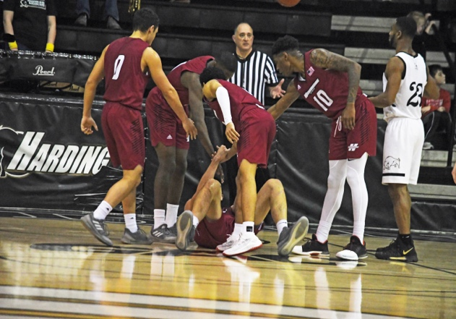

“

Parent’s Name Phone # Emergency Phone # Email address Address/City/ State/ Zip Code

Birth Date 2025-26 Grade

School

T-shirt Size—CS CM CL AS AM AL AXL AXXL “I hereby acknowledge that participation in the camp

and related activities involves an inherent risk of physi- cal injury or loss that might be sustained by my child.

In consideration for accepting my child into the camp, I

assume all risk of injury and loss that may be suffered by me or my child and release and forever discharge the Board of Trustees of Henderson St. University, its officers, employees and agents from any and all known liability of whatever kind or nature, arising from and by reason of any and all known and unknown, foreseen and unforeseen body and personal injuries, including death, property damage and the consequences there- fore resulting from the registrants' participation in or involvement with this camp or presence on university property, including any failure of equipment or defect in the premises, except to extent caused solely by the willful and wanton misconduct of the university.

I give permission to Henderson St. University to take photographs and videos of my child during the course

of camp activities. These photographs may be used for publicity purposes by Henderson St. University. “

Parent Signature

___ HSU Shooting Camp June 23-24 ($80)

___ HSU Elite Fundamental June 23-24 ($80)

___ HSU Day Camp June 9-12 ($125)

___ HSU Shooting Camp 2 July 21-22 ($80)

___ HSU Elite Fundamental 2 July 21-22 ($80)

**To Reserve Your Spot:**

**Online:**

Visit hsubasketball.com

$50 deposit required to reserve spot

**Mail:**

Complete registration and enclosed

release form with $50 deposit and

mail to:

Reddie Basketball Camp

Attn. Jimmy Elgas

1100 Henderson St., Box 7630

Arkadelphia, AR 71999

Call Tamara Elgas at 785-532-9368 or email [tamdge@yahoo.com](mailto:tamdge@yahoo.com) with questions.

Make checks payable to : Reddie Basketball Camp

Full payment is due the first day of

camp.